Personal Working Planning
To track my tasks and make a better planning for this semester I decided to use Jira, I used this method last semester and it proved quite efficient. 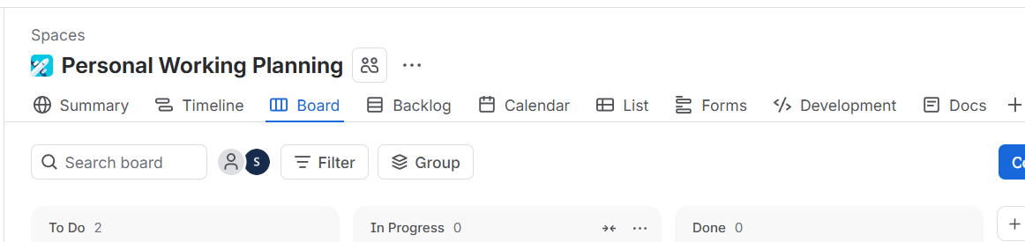
The planning will consist of a few statuses for different tasks. The first one is “To Do”:
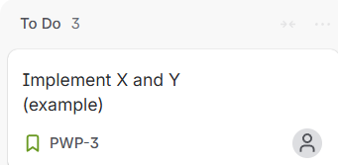
This is where tasks that need to be done will appear at first. This section will mean that this task is at absolute beginning and work has not been stated on it yet.
On the other had the next logical step is for the next phase to be “In Progress”: 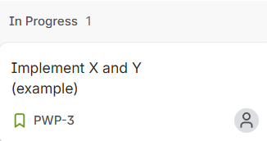
Once developent on the task has started it would be moved here. This means that currently it is being actively worked on.
The next status of course is “Done”:
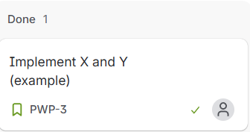
Once fully completed a task will be moved here. It will mean that the task is technically ready, but still has to be documented in the next step. And that step Is called “Documenting”:
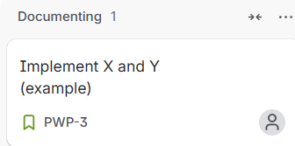
During the Documenting Step the task needs to be Documented in a Word Doc, after that it needs to be uploaded in the portfolio and Evidence Description needs to be added. Only then do we reach the last part of the task, which is “Submitted”:
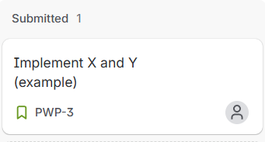
This means that the task has been done, documented and submitted in the portfolio successfully.

